J meter:

Controllers (containers to store the request)

1. Transaction controller

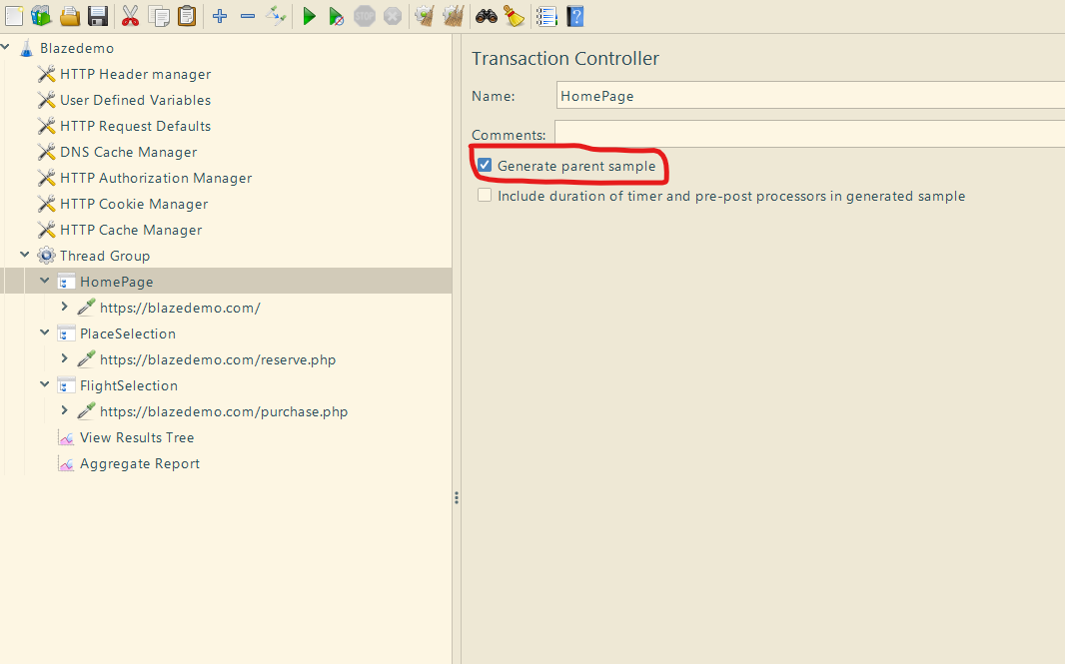

Note:

If we checkin the “generate parent sample” we will get the whole transaction result

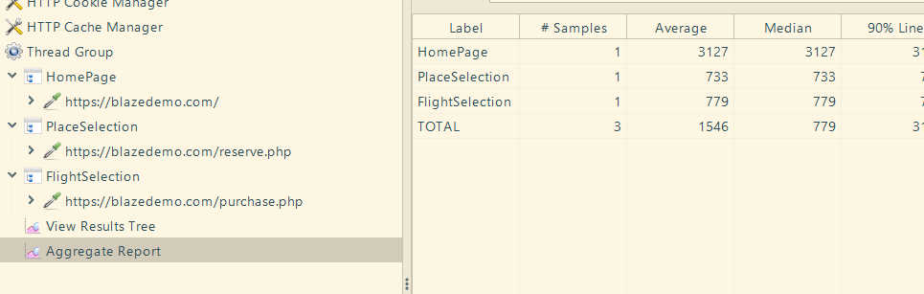

(Here, one VU is accessing the homepage, one VU place selection, one VU flight selection)

1. Simple Controller :

Its normal controller we will see each and every request

1. Module Controller:

(Script re-usability )

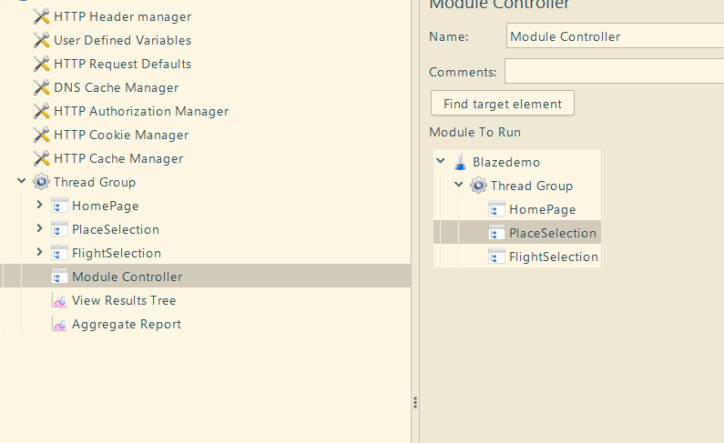

1. Interleave controller and Random controller

Execution flow

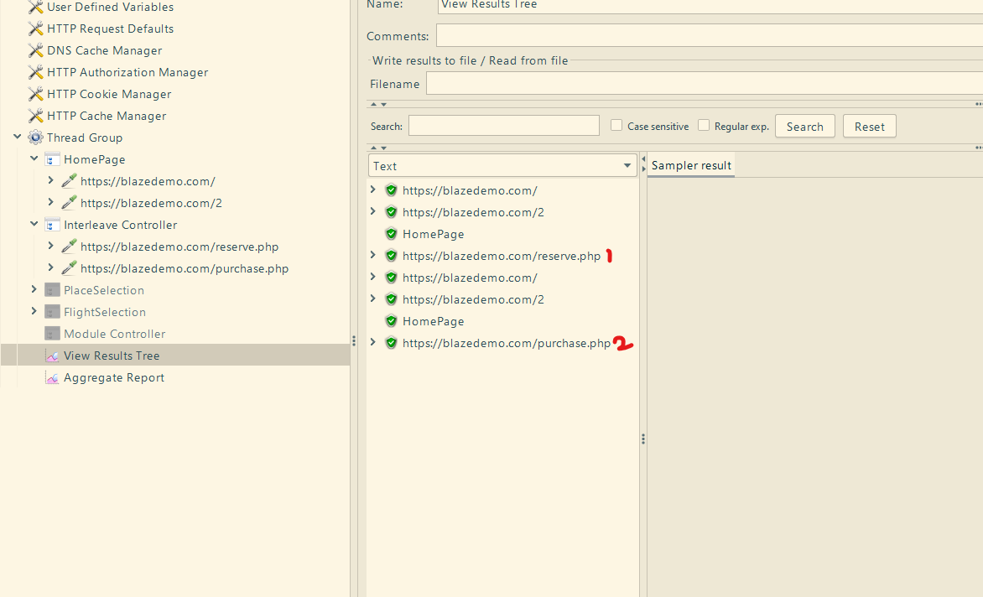

Note:

* Take a look on the loop count in thread group
* Request in the Interleave controller will execute only once for an iteration

1. Throughput controllers:

(For distributing the load test)

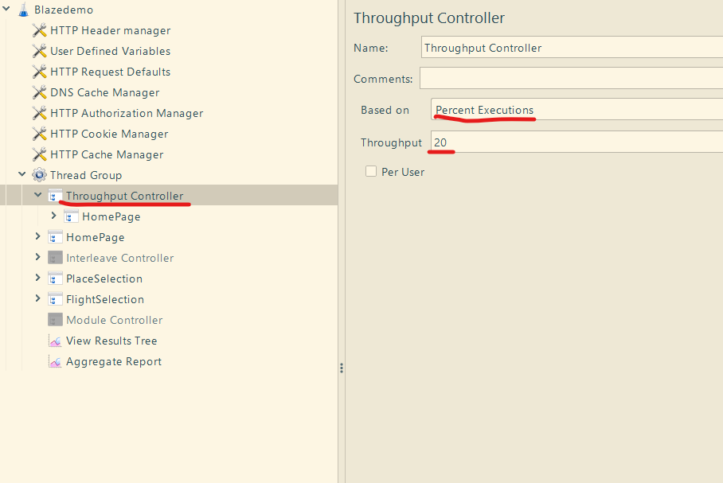

1. Runtime controller

(Giving a specific amount of time to run a particular request)

Pacing:

* Controlled ramp-up and ramp-down of virtual users
* Control timing between iterations
* Achieve x iterations in y mins/sec

Config Elements:

1. CSV Data set Config

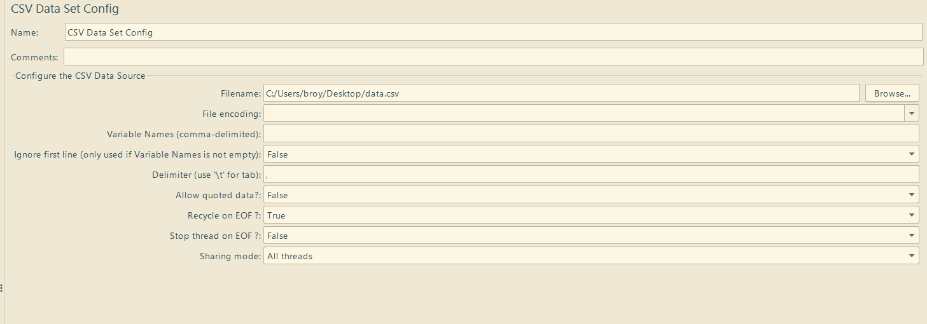

Step 1: Browse the file

Plugin Manager:

Step 1: Go to <https://jmeter-plugins.org/wiki/PluginsManager/>

Click “jar file” link and place the file in the lib/ext

Step 2: options-> plugin manager ->available plugin -> custom thread group -> Apply changes and restart

Concurrency thread group

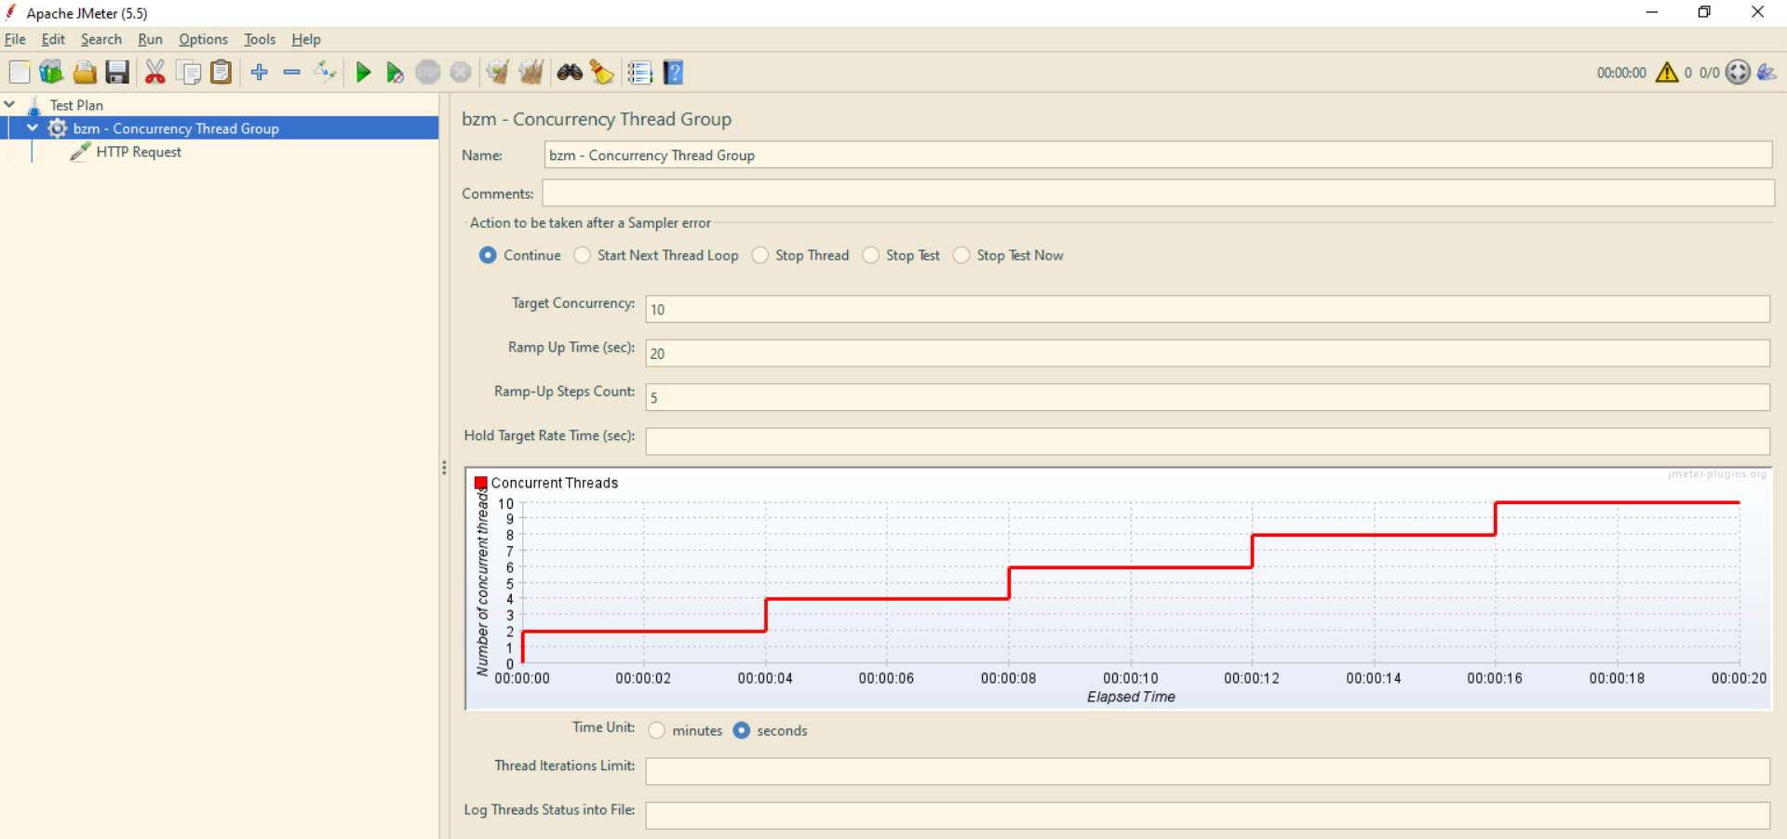

Creating HTML report from command line and GUI

Step 1: Create a test plan or use existing test plan

Step 2: Open cmd line go to jmeter bin folder

Step 3: Run commands

Jmeter –n –t “location of jmx script file” –l “location of result file” –e –o “location of reports folder”

For existing

Jmeter –g “location of result file” –o “location of reports folder”

Eg: jmeter -n -t "C:\Users\broy\Downloads\herokuapp.jmx" -l "C:\Users\broy\Desktop\Result1.csv" -e -o "C:\Users\broy\Desktop\Reports1"

In HTML report , graph -> elaspsed time we can change the time by going to bin-> reportgenerator.properties file -> search for granularity

Bin-> apdex -> threshold

\*For scripting console you need to open the jmeter console in bin folder